PROJECT REPORT
ON
“POSHAN SHAKTI : MID-DAY MEAL NUTRITION TRACKING AND DONATION MANAGEMENT SYSTEM”

Submitted in partial fulfillment of the requirements
for the award of the degree of

BACHELOR OF COMPUTER APPLICATION(BCA)
To
UTTARANCHAL SCHOOL OF COMPUTING SCIENCES


SESSION (2025-2026)

Submitted To: Submitted By:
Ms Vaibhavi Kaushik Rashmi
Assistant professor Bca-IV ‘D’
USCS enrolment No:
UU243609000255

ACKNOWLEDGEMENT

The most awaited moment of any endeavour is successful completion, but nothing can be done successfully if done alone. Success is the outcome of the contribution and consistent help of various persons and we thank those who helped us in the successful completion of this project. Primarily I would like to thank Prof. (Dr) Sonal Sharma, Director USCS for providing a healthy and encouraging environment to study. I profusely thankful to the department of computing Science, and Prof. (Dr.) Sameer Dev Sharma, HOD, and my Project Mentor Ms. Vaibhavi Kaushik.

Rashmi

DECLARATION

I, Rashmi, student of Bachelor of Computer Application (BCA), hereby declare that the project entitled "POSHAN SHAKTI: Mid-Day Meal Nutrition Tracking and Donation Management System" submitted to the Department of Computer Application, University School of Computer Science (USCS), is a record of original work done by me under the guidance of my project mentor, Ms. Vaibhavi Kaushik, Assistant Professor.

This project has been undertaken as part of my curriculum in partial fulfilment of the requirements for the award of the degree of Bachelor of Computer Application. I affirm that the work presented in this project is my own and has not been submitted previously for the award of any degree or diploma in any other institution. I also declare that all sources of information used in this project have been duly acknowledged.

Rashmi
BCA, IV ‘D’

CERTIFICATE OF ORIGINALITY

This is to certify that Rashmi, student of BCA IV Semester, of Uttaranchal School of Computing Sciences, Dehradun, has completed the Project "POSHAN SHAKTI: Mid-Day Meal Nutrition Tracking and Donation Management System" The results embodied in this project have not been submitted to any other University or Institution for the record of any degree.

Under the guidance of
Ms. Vaibhavi Kaushik
Assistant Professor
USCS
Uttaranchal University

Rashmi
BCA IV ‘D’
USCS,
Uttaranchal University

TABLE OF CONTENTS

SR.NO. | CONTENTS | PAGE NO.
1 | ACKNOWLEDGEMENT | II
2 | DECLARATION | III
3 | CERTIFICATE OF ORIGINALITY | IV
4 | INTRODUCTION | 1
5 | OBJECTIVES | 2
6 | SYSTEM ANALYSIS | 3-14
6.1 | IDENTIFICATION OF NEED | 3
6.2 | PRELIMINARY INVESTIGATION | 4
6.3 | FEASIBILITY STUDY | 15
6.4 | PTOJECT PLANNING | 6
6.5 | PROJECT SCHEDULING | 7-8
6.6 | SRS | 9-10
6.7 | SOFTWARE ENGINEERING PARADIGM | 11
6.8 | DATA MODELS | 12-14
7 | SYSTEM DESIGN | 15-22
7.1 | MODULARISATION DETAILS | 15-16
7.2 | DATA INTEGRITY AND CONSTRAINTS | 17
7.3 | DATABASE DESIGN | 18-19
7.4 | UI DESIGN | 20-22
8 | TESTING | 23-26
8.1 | TECHNIQUES AND STRATEGIES | 23
8.2 | TEST REPORTS | 24-26
9 | SYSTEM SECURITY MEASURES | 27
10 | COST ESTIMATION | 28
11 | REPORTS | 29-30
12 | FUTURE SCOPE AND ENHANCEMENTS | 31
13 | APPENDICES | 32-47
13.1 | CODING | 32-46
13.2 | BIBLIOGRAPHY | 47

INTRODUCTION

Poshan Shakti is a web-based Mid-Day Meal Nutrition Tracking and Donation Management System designed to help government schools across India monitor the nutritional health of students enrolled in the Mid-Day Meal (MDM) scheme. The Mid-Day Meal programme, launched by the Government of India, is one of the largest school nutrition programmes in the world, providing cooked meals to over 120 million children daily across primary and upper primary schools.

Despite its scale, the programme faces challenges in tracking the actual nutritional content of meals served, monitoring student health indicators such as Body Mass Index (BMI), and managing donations that support the scheme. Most schools still rely on manual registers or basic spreadsheets, making it difficult to generate insights, identify malnourished students, or track donor contributions effectively.

Poshan Shakti addresses these gaps by providing a clean, intuitive web interface with four core modules: Student Records, Mid-Day Meal Logging, Nutrition and BMI Analysis, and Donation Management. The system allows NGO workers and school administrators to add student data, log daily meals with specific food items such as roti, sabzi, milk, egg, dal, and rice, analyse nutrition levels, and record donor contributions.

The frontend of the system is built using HTML5, CSS3, Bootstrap 5, and JavaScript. Data is stored in the browser's localStorage, making it fully functional without any server setup. A backend infrastructure using Java Servlets, Apache Tomcat 10, and MySQL 8.0 has also been designed to support real-world multi-user deployment.

OBJECTIVES

- To develop a digital student health monitoring system that records and tracks individual student data.

- To implement an automated Mid-Day Meal nutrition tracking module that allows school administrators to log daily meals.

- To design a real-time nutrition analysis and health alert system that identifies malnourished and severely underweight students.

- To build a transparent donation management system that records monetary and food donations received from individuals and organisations.

- To create a secure, browser-based web application using HTML5, CSS3, Bootstrap, and JavaScript.

SYSTEM ANALYSIS

1. IDENTIFICATION OF NEED: -

The Mid-Day Meal scheme is a critical government initiative aimed at improving nutritional intake and school attendance among children in India. However, several operational challenges limit its effectiveness:
- School administrators have no digital system to record student health data such as height, weight, and BMI.
- There is no mechanism to track the specific food items served daily or calculate their nutritional value per student.
- Identifying malnourished or severely underweight students requires manual assessment without any automated alerting.
- Donations received from NGOs, individuals, or government bodies are recorded manually in paper registers with no transparency or reporting.
- Without a centralised system, data cannot be aggregated, analysed, or shared across schools or districts.

Poshan Shakti directly addresses these needs by digitalising the entire process from student enrolment and meal logging to nutrition analysis and donation tracking, all within a single browser-based interface.

2.PRELIMINARY INVESTIGATION: -

The preliminary investigation phase involved understanding the existing processes used in government schools for Mid-Day Meal tracking and identifying gaps that a digital system could address.

1. Problem Identification: Discussions with school administrators and NGO workers revealed that most schools maintain paper registers for student attendance and meal records. There is no mechanism to correlate meal composition with student health outcomes. Malnourished students are identified only during annual health check-ups, leaving a large gap in continuous monitoring.

2. Existing System Analysis: Currently, the National Programme of Mid-Day Meals in Schools (MDMS) provides guidelines for calorie and protein content per meal. However, schools have no digital tool to verify whether the meals being served actually meet these guidelines. Commercial nutrition tracking applications are too complex and expensive for school-level use.

3. Proposed System Overview: The proposed Poshan Shakti system fills this gap with a simple, four-module web application that does not require any specialised hardware or software training. A school administrator or NGO worker with basic computer skills can operate the system fully.

3. FEASIBILITY STUDY: -
The feasibility study examines whether the Poshan Shakti system can be effectively developed and deployed within the available resources and constraints.

1. Technical Feasibility: The project uses only open-source and freely available technologies — HTML5, CSS3, Bootstrap 5, JavaScript, Java JDK, Apache Tomcat, and MySQL. All these tools are widely used, well-documented, and fully supported on standard Windows and Linux systems. The localStorage-based frontend requires no server at all for demonstration. The system is technically feasible.

2. Operational Feasibility: The system is designed for users with basic computer literacy. The interface uses simple forms, clickable food tiles, and colour-coded status badges that require no training. NGO workers can log meals, add students, and view reports within minutes of using the system. The system is operationally feasible.

3. Economic Feasibility: All technologies used in the project are free and open source. There are no licensing fees, no paid APIs, and no hardware requirements beyond a standard computer and browser. The total development cost is essentially zero beyond student time. The system is economically feasible.

4. Time Feasibility: The project was developed over approximately three months from February to April 2026, which is sufficient for a mini project of this scope. The development was divided into clear phases as shown in the Gantt Chart. The system is time feasible.

4.PROJECT PLANNING: -
The project planning phase outlines the development approach, scope, and work breakdown for the Poshan Shakti system.

1. Project Objectives: To develop a working, browser-based web application for Mid-Day Meal nutrition tracking with four fully functional modules: Students, Mid-Day Meal Log, Nutrition Analysis, and Donations.

2. Scope of Work: The scope includes designing all HTML pages, implementing JavaScript logic for data handling, building the BMI calculation engine, creating the food nutrition database, and integrating all modules into a cohesive interface. The backend Java Servlet architecture is also designed as part of the scope for future deployment.

3. Project Phases :
Phase 1:
Requirement Analysis
Phase 2:
System Design
Phase 3:
Development / Implementation
Phase 4:
Testing & Debugging
Phase 5:
Documentation
Phase 6: Review and Submission

4. Work Breakdown Structure (WBS): The work was divided into the following phases:
- Phase 1: Requirement gathering and analysis (Feb Week 1)
- Phase 2: System design and wireframing (Feb Week 2)
- Phase 3: Database schema design (Feb Week 3)
- Phase 4: Frontend development — all HTML, CSS, JS modules (Feb Week 4 to Mar Week 2)
- Phase 5: Individual module development — Students, Meals, Nutrition, Donations (Mar Week 1-4)
- Phase 6: Integration, testing, and bug fixing (Apr Week 1-3)
- Phase 7: Documentation and report writing (Apr Week 4)

Project Scheduling — Gantt Chart (February to April 2026)
Task / Phase | Start | End | Feb | Mar | Apr | Period
Requirement Analysis | Feb 01 | Feb 07 | ████ |  |  | Feb Week 1
System Design & Planning | Feb 08 | Feb 16 | ████ |  |  | Feb Week 2
Database Design | Feb 17 | Feb 22 | ████ |  |  | Feb Week 3
Frontend Development | Feb 23 | Mar 15 | ████ | ████ |  | Feb Wk4–Mar Wk2
Students Module | Mar 01 | Mar 10 |  | ████ |  | Mar Week 1
Mid Day Meal Module | Mar 10 | Mar 20 |  | ████ |  | Mar Week 2
Nutrition Analysis Module | Mar 20 | Mar 28 |  | ████ |  | Mar Week 3
Donation Module | Mar 28 | Apr 05 |  | ████ | ████ | Mar Wk4–Apr Wk1
Integration & Testing | Apr 05 | Apr 15 |  |  | ████ | Apr Week 2
Bug Fixing & Refinement | Apr 15 | Apr 22 |  |  | ████ | Apr Week 3
Documentation & Report | Apr 22 | Apr 30 |  |  | ████ | Apr Week 4

Project Scheduling — PERT chart (February to April 2026)

The PERT chart illustrates the sequence of project activities, their dependencies, and the estimated duration of each task from February to April 2026, with the critical path highlighted to show the minimum time required to complete the project.
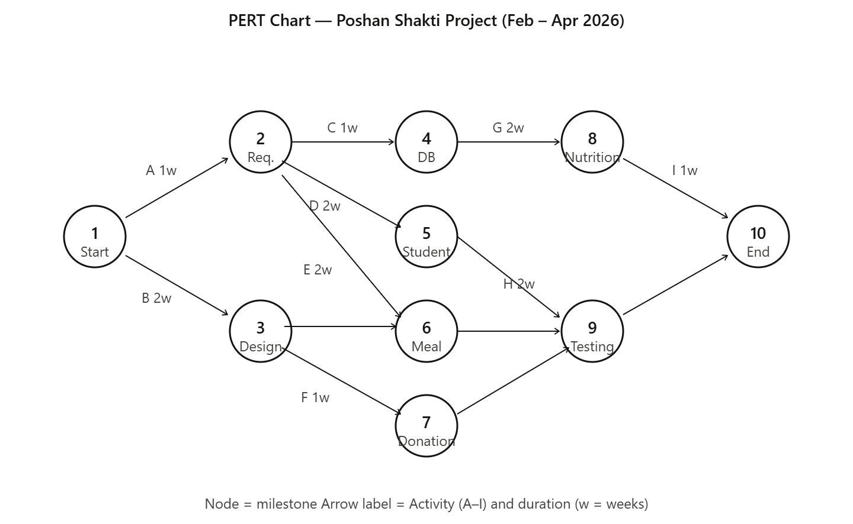

5. SOFTWARE REQUIREMENT SPECIFICATIONS (SRS): -

Functional Requirements (FR):
- Student Management: The system shall allow users to add student records including name, age, gender, class, roll number, height, weight, and school name. BMI shall be calculated and stored automatically.

- Mid-Day Meal Logging: The system shall allow users to select food items served (roti, sabzi, milk, egg, dal, rice, khichdi, poha, banana) and enter quantities. Calorie, protein, carbohydrate, and fat values shall be calculated automatically per student.

- Nutrition Analysis: The system shall display BMI status for each student, generate alerts for students with BMI below 16 (severely underweight), and display a calorie bar chart for the last 7 meal logs.

- Donation Management: The system shall allow recording of money donations (with amount in Rs.) and food donations (with item description), along with donor contact details and optional messages.

- NGO Login: The system shall provide a login page for NGO administrators. Authentication shall validate username and password credentials.

- Dashboard: The homepage shall display live counts of total students, meals logged, and donations recorded.

Non-Functional Requirements (NFR):
- Usability: The interface shall be operable by users with basic computer literacy without training.

- Performance: Pages shall load within 2 seconds on a standard broadband connection.

- Compatibility: The system shall function on Chrome, Firefox, and Edge browsers without plugins.

- Responsiveness: The layout shall adapt to desktop, tablet, and mobile screen sizes.

- Data Integrity: BMI and nutrition values shall be calculated using standard formulas without manual input errors.

- Scalability: The backend architecture shall support multi-school, multi-user deployment.

6. SOFTWARE ENGINEERING PARADIGM: -

The Poshan Shakti system adopts the Waterfall Model as its software engineering paradigm. This linear, structured approach was chosen because the project requirements were clearly defined at the beginning and did not change significantly during development.

The development proceeded through the following sequential phases:
- Requirement Analysis: All functional and non-functional requirements were gathered and documented before any development began.
- System Design: The database schema, module architecture, and UI wireframes were designed based on the requirements.
- Implementation: HTML, CSS, JavaScript, and Java code was written module by module in the order of Student, Meal, Nutrition, and Donation.
- Testing: Each module was tested independently (unit testing) and then together (integration testing).
- Documentation: The project report was written after development and testing were complete.

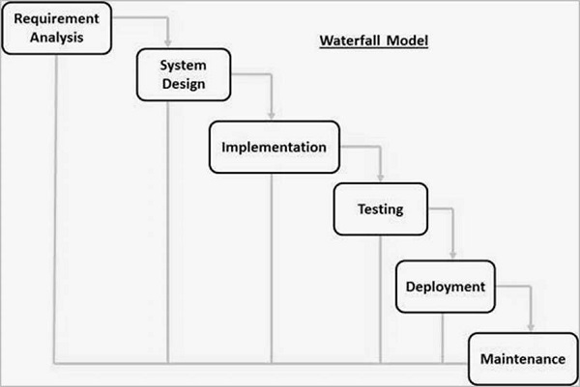
The Waterfall model ensured a predictable development timeline, clear milestones, and well-organised documentation — all of which are appropriate for an academic mini project of this scale.

7. DATA MODELS: -

- DATA FLOW DAIGRAM(DFD): -

1. 0 level DFD

Level 0 is the Context Diagram. It shows the entire system as a single process .

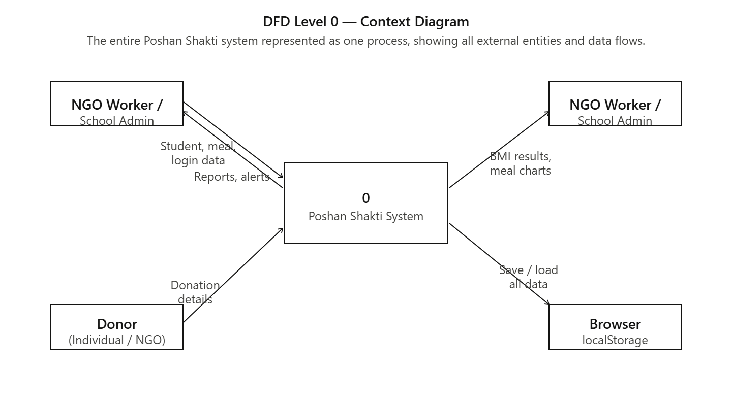

2. 1 level DFD

Level 1 — Main Processes. This diagram breaks the system into its four core modules, showing how data flows between each process and the data stores.

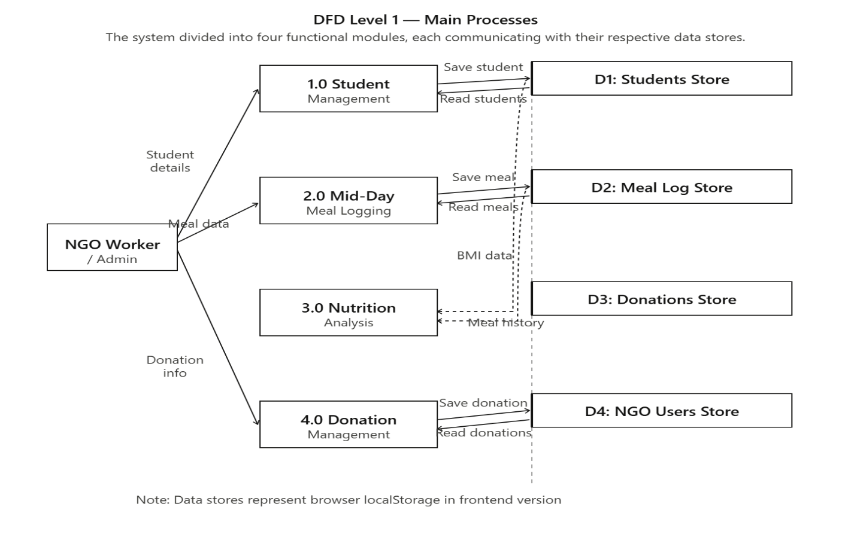
3. 2 level DFD

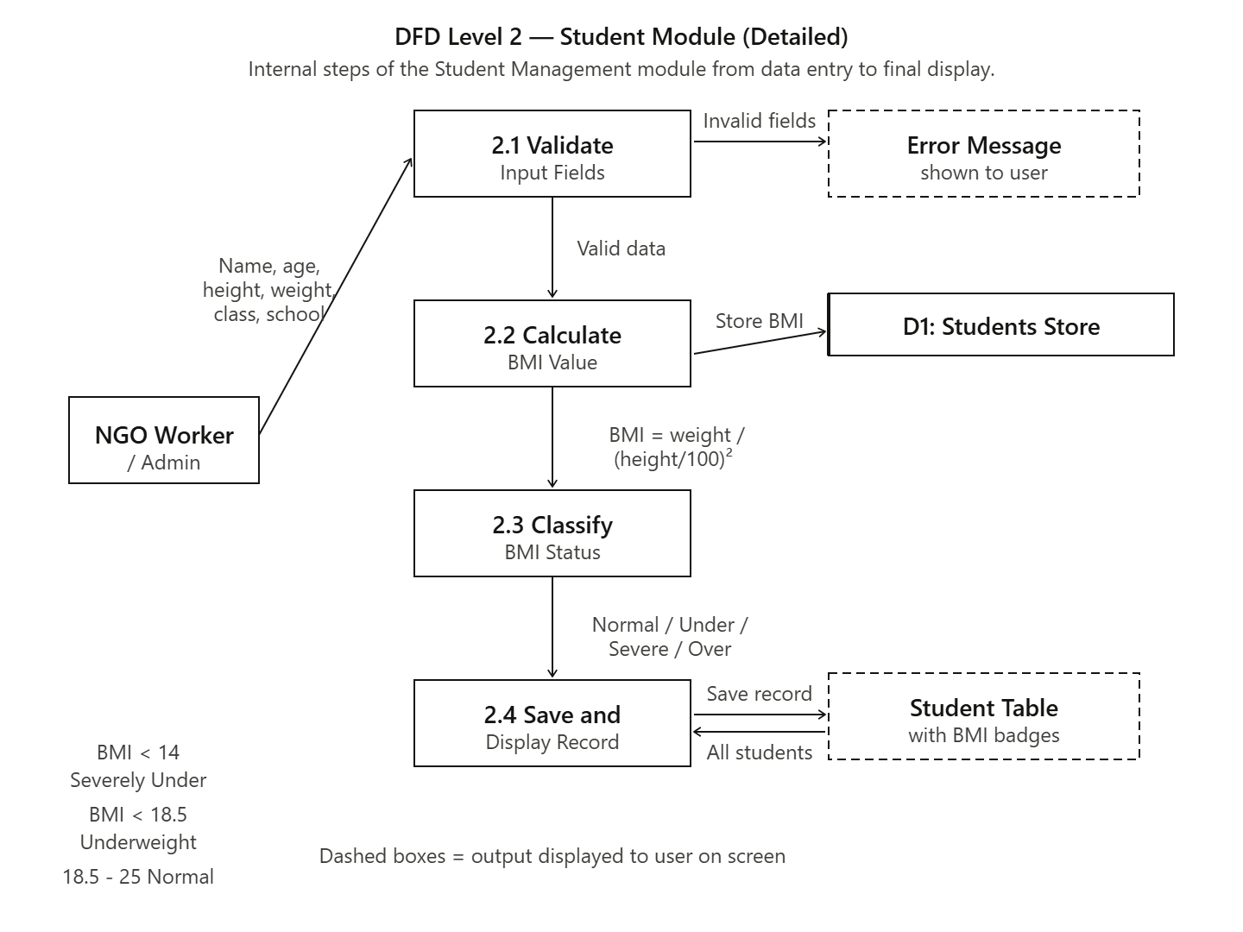

- ER DIAGRAM: -

The ER diagram shows four entities — Students, Meal_Log, Donations, and NGO_Users — stored as JSON arrays in browser localStorage, with Students and Meal_Log linked by class name, and Meal_Log records analysed by the Nutrition module.

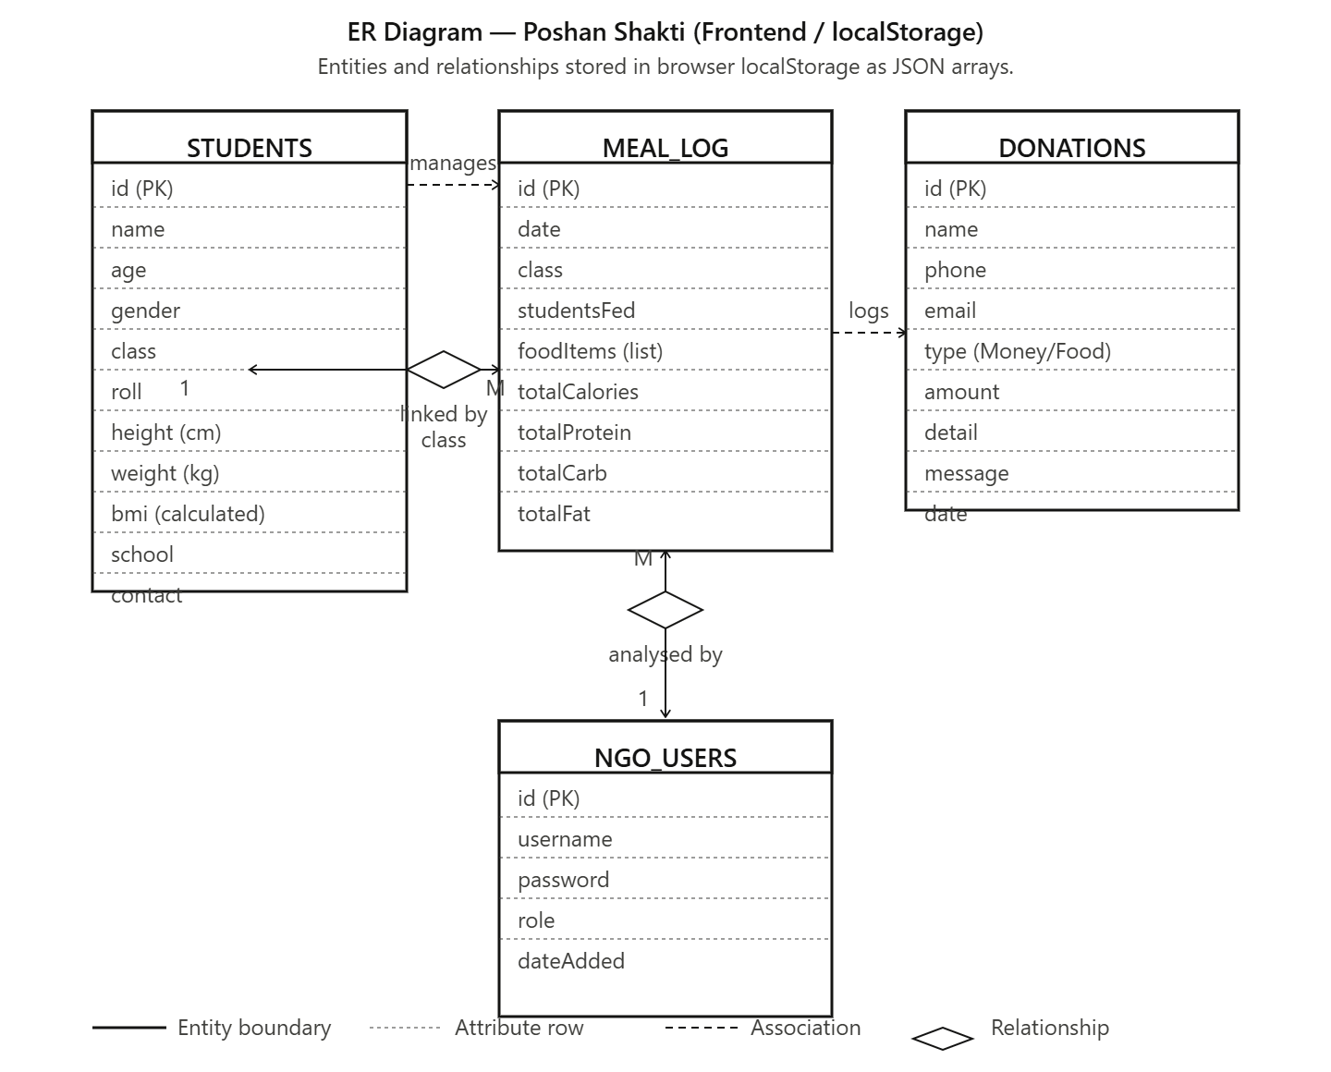

SYSTEM DESIGN

1. Modularisation Details: -
The Poshan Shakti system is divided into six independent modules, each handling a specific set of responsibilities. This modular design ensures maintainability, easy debugging, and the ability to extend functionality in future versions.

Module 1 — Student Management (students.html)
This module handles the complete lifecycle of student records. Users can add a new student by filling in the student form with name, age, gender, class, roll number, height (cm), weight (kg), and school name. The module automatically calculates BMI using the formula BMI = weight / (height in meters) ^2 and classifies the result into one of four categories. Students are displayed in a searchable table with colour-coded BMI badges. Individual student records can be deleted.

Module 2 — Mid-Day Meal Logging (midday.html)
This module allows users to record the daily meal served to students. The user selects the date, class, and number of students fed, then clicks on food tile buttons representing individual food items — Roti, Rice, Dal, Sabzi, Milk, Egg, Banana, Khichdi, and Poha. After selecting food items, quantity inputs appear for each selected item. The system automatically calculates total calories, protein, carbohydrates, and fat per student using a built-in nutrition database. The meal is saved and appears in the Meal History table.

Module 3 — Nutrition and BMI Analysis (nutrition.html)
This module provides an analytical view of student health. It displays a summary dashboard showing total students, number with normal BMI, underweight students, and severely underweight students. A red alert box automatically appears listing all students with BMI below 16 (severely underweight), along with their contact information for immediate action. A bar chart shows calorie levels from the last 7 meal logs. The student table can be filtered by class, BMI status, and student name.

Module 4 — Donation Management (donation.html)
This module records donations received from individuals or organisations. Donations can be of three types: Money (with Rs. amount and quick-select buttons for Rs.100, Rs.500, Rs.1000, Rs.5000), Food Items (with a description of food donated), or Other (with a custom description). The total money raised is displayed prominently at the top of the donation records section. All donation records can be viewed and deleted.

Module 5 — NGO Login (login.html)
This module provides secure access to the system. The login page uses the school background image with a white overlay and a clean login box. Default credentials are admin / poshan123. In the frontend-only version, authentication is handled via JavaScript. In the backend version, the LoginServlet validates credentials against the ngo_users table in MySQL and creates a session upon successful login.

Module 6 — Dashboard / Homepage (index.html)
The homepage serves as the entry point and provides an overview of the system. It features the POSHAN SHAKTI navbar with green branding, a large hero title, a live statistics strip showing total students, meals logged, and donations, and three clickable image cards linking to the Mid-Day Meal, Students, and Nutrition modules.

2. DATA INTEGRITY AND CONSTRAINTS
The Poshan Shakti system enforces the following data integrity rules:

Field | Constraint | Enforcement
Student Name | Not null, minimum 2 characters | JavaScript validation before save
Age | Integer, 5 to 18 years | HTML input min/max + JS validation
Height | Decimal, 80 to 200 cm | JS validation
Weight | Decimal, 10 to 100 kg | JS validation
BMI | Auto-calculated, stored to 1 decimal | Formula: weight/(height/100)^2
Gender | Must be Boy or Girl | Dropdown — no free text
Class | Must be Class 1 to Class 8 | Dropdown — no free text
Meal Date | Not null, defaults to today | HTML date input with default
Students Fed | Integer, minimum 1 | HTML min attribute + JS validation
Food Items | At least one must be selected | JS checks Object.keys(selected).length
Donor Name | Not null | JS validation before save
Donation Amount | Positive number for Money type | JS validation

3.DATABASE DESIGN: -
The MySQL database for Poshan Shakti is named poshan_shakti and contains four tables:
Table 1: students
Column | Data Type | Constraint | Description
id | INT | PRIMARY KEY, AUTO_INCREMENT | Unique student ID
name | VARCHAR(100) | NOT NULL | Full name of student
age | INT |  | Age in years
gender | VARCHAR(10) |  | Boy or Girl
class_name | VARCHAR(20) |  | Class 1 to Class 8
roll_number | VARCHAR(20) |  | School roll number
height_cm | DECIMAL(5,1) |  | Height in centimetres
weight_kg | DECIMAL(5,1) |  | Weight in kilograms
bmi | DECIMAL(4,1) |  | Calculated BMI value
school_name | VARCHAR(150) |  | Full school name
parent_contact | VARCHAR(15) |  | Parent mobile number
date_added | DATE |  | Date of enrolment

Table 2: meal_log
Column | Data Type | Constraint | Description
id | INT | PRIMARY KEY, AUTO_INCREMENT | Unique meal record ID
meal_date | DATE | NOT NULL | Date meal was served
class_name | VARCHAR(20) |  | Target class
students_fed | INT |  | Number of students who received meal
food_items | TEXT |  | Comma-separated list of food served
total_calories | INT |  | Calories per student
total_protein | DECIMAL(6,2) |  | Protein in grams
total_carb | DECIMAL(6,2) |  | Carbohydrates in grams
total_fat | DECIMAL(6,2) |  | Fat in grams
logged_at | TIMESTAMP | DEFAULT CURRENT_TIMESTAMP | Auto-recorded timestamp

4. USER INTERFACE DESIGN: -
HTML5 + CSS3 + Bootstrap 5 + JavaScript based web interface provides:
- Main Menu / Dashboard:
• Homepage displaying the project title "Mid-Day Meal Nutrition Tracking and Donation Management System" with a background watermark image.
• Live statistics strip showing total students enrolled, total meals logged, and total donations received — updated automatically from localStorage.
• Three clickable image cards linking directly to Mid-Day Meal, Students, and Nutrition Tracking modules.
• Green navbar with POSHAN SHAKTI branding, NGO Login button, and Donate button visible on every page.
- Student Module Flow:
• Fill add-student form with name, age, gender, class, roll number, height, weight, school name, and parent contact.
• System automatically calculates and displays BMI using the formula weight / (height/100) ².
• BMI status classified and shown as a colour-coded badge — Normal, Underweight, Severely Underweight, or Overweight.
• All enrolled students displayed in a searchable table with filter by name.
• Individual student records can be deleted with a confirmation prompt.

- Mid-Day Meal Module Flow:
• Select date and class, enter number of students fed.
• Click food tile buttons to select items served — Roti, Rice, Dal, Sabzi, Milk, Egg, Banana, Khichdi, Poha.
• Quantity input fields appear dynamically for each selected food item.
• Live nutrition preview updates automatically showing total calories, protein, carbohydrates, and fat per student.
• Saved meals appear in the Meal History table with food tags and nutritional summary.

- Nutrition Analysis Panel:
• Summary cards at the top showing total students, normal BMI count, underweight count, and severely underweight count.
• Red health alert box automatically appears listing all students with BMI below 16 along with their contact details for immediate action.
• Bar chart showing calorie levels from the last 7 meal logs for visual trend analysis.
• Student nutrition table filterable by class, BMI status, and student name with recommended daily calorie intake shown per student.

- Donation Management Flow:
• Select donation type — Money, Food Items, or Other — from dropdown.
• For money donations, quick-select buttons for Rs.100, Rs.500, Rs.1000, Rs.5000 available.
• Food and Other donation types show relevant description input dynamically.
• Total money raised displayed prominently at the top of the donation records section.
• All donation records displayed in a table with donor name, type, details, and message.

- NGO Login Page:
• School background image with white overlay for clean professional appearance.
• Login form with username and password fields.
• Demo credentials displayed for testing — admin / poshan123.
• Invalid credentials show an inline error message without page reload.
• Successful login redirects to the homepage dashboard.

TESTING

1.TESTING TECHNIQUES AND STRATEGIES USED: -

The Poshan Shakti system was tested using the following strategies:

1. Unit Testing: Each module was tested independently before integration. The BMI calculation formula was verified against known values. The food nutrition calculation was checked against standard nutrition tables.

2. Integration Testing: All four modules were tested together to verify that data flows correctly — for example, students added in the Students module appear in the Nutrition Analysis module with correct BMI classification.

3. Boundary Value Testing: Edge cases were tested such as minimum height (80 cm), maximum weight (100 kg), BMI exactly at 14 (severely underweight boundary), and zero students fed.

4. User Acceptance Testing (UAT): The system was demonstrated to a sample user (fellow student) who was asked to add students, log meals, and record a donation without any guidance. All tasks were completed successfully within 10 minutes.

5. Browser Compatibility Testing: The system was tested on Google Chrome (v124), Microsoft Edge (v124), and Mozilla Firefox (v125). All pages rendered correctly on all three browsers.

2. TEST REPORTS: -

1. Unit Test Cases — Student Module:
TC# | Test Case | Input | Expected Output | Status
TC01 | Add student with all valid inputs | Name: Rahul, Age: 10, Gender: Boy, Class: 5, Height: 130, Weight: 25, School: GPS Delhi | Student saved, BMI = 14.8 displayed as Underweight | PASS
TC02 | Add student with missing name | All fields filled except name | Alert: Please fill all required fields | PASS
TC03 | Add student with missing height | Name, age, gender filled, height empty | Alert: Please fill all required fields | PASS
TC04 | BMI calculation accuracy | Height: 140 cm, Weight: 35 kg | BMI = 35 / (1.40^2) = 17.9 — Underweight | PASS
TC05 | BMI = 13 — Severely Underweight alert | Height: 120, Weight: 18.7 kg | BMI = 13.0, red badge, appears in alerts | PASS
TC06 | Search student by name | Type 'Rah' in search box | Only students with 'Rah' in name shown | PASS
TC07 | Delete student | Click Delete on any student row | Confirmation dialog, then student removed | PASS

2. Unit Test Cases — Mid-Day Meal Module:
TC# | Test Case | Input | Expected Output | Status
TC08 | Log meal with no food selected | Date and students filled, no food tiles clicked | Alert: select at least one food item | PASS
TC09 | Log roti (2 pieces) per student | Select Roti, quantity = 2 | Calories = 160 kcal, Protein = 5g displayed | PASS
TC10 | Log meal with multiple food items | Roti x2, Dal x150ml, Milk x200ml | Correct total calories calculated | PASS
TC11 | Log meal with zero students fed | Students fed = 0 | Alert: Number of students must be at least 1 | PASS
TC12 | Meal appears in history | Save any valid meal | Meal row appears in Meal History table | PASS
TC13 | Delete meal record | Click Delete on meal row | Confirmation dialog, meal removed from table | PASS

3. Integration Test Cases:
TC# | Test Case | Input | Expected Output | Status
TC14 | Student appears in Nutrition page | Add student in Students module | Same student visible in Nutrition Analysis table | PASS
TC15 | Meal appears in calorie chart | Log meal in Midday module | Bar appears in calorie chart on Nutrition page | PASS
TC16 | Donation count on homepage | Add donation | Donations count on homepage increments by 1 | PASS
TC17 | Login with correct credentials | admin / poshan123 | Redirect to homepage | PASS
TC18 | Login with wrong password | admin / wrongpass | Error message shown | PASS

SYSTEM SECURITY MEASURES

The following security measures have been implemented in the Poshan Shakti system:

- Authentication: The NGO Login module requires a valid username and password before accessing the system. In the backend version, credentials are validated against the MySQL ngo_users table using a PreparedStatement to prevent SQL injection attacks.
- Input Validation: All form inputs are validated both in the HTML (using required attributes, min/max values, and type constraints) and in JavaScript before data is saved. This prevents empty or malformed data from entering the system.
- SQL Injection Prevention: The Java Servlet backend uses PreparedStatement with parameterised queries for all database operations, completely eliminating the risk of SQL injection.
- Session Management: In the Tomcat backend version, login creates a server-side session using HttpSession. The session is destroyed on logout.
- No Sensitive Data Exposure: The system does not store passwords in plain text in source code visible to users. The DBConnection.java file reads the database password from an environment variable (DB_PASS) in production configuration.
- Data Confirmation: Delete operations (student, meal, donation) require user confirmation via a browser dialog box, preventing accidental data loss.
- CORS Headers: The Java Servlets include Access-Control-Allow-Origin headers to control which origins can access the API endpoints.

COST ESTIMATION

Cost Estimation Model Used — COCOMO Model (Basic).
The COCOMO Model (Constructive Cost Model), proposed by Barry W. Boehm, is used to estimate the effort and time required to develop a software project based on the size of the codebase measured in Lines of Code (LOC).
For the Poshan Shakti system, the Basic COCOMO Model is applied since this is a small, well-understood academic project with clearly defined requirements. Under Basic COCOMO, projects are classified into three modes:
- Organic — small, simple projects developed by small teams with good experience. Poshan Shakti falls under this category as it is a frontend web project developed individually with familiar technologies.
- Semi-detached — medium complexity projects with some experience.
- Embedded — highly complex projects with strict hardware and software constraints.

The Poshan Shakti system was developed at zero direct financial cost by utilising open-licensed and publicly available web technologies. The COCOMO Basic Model estimates an effort of approximately 3.28 person-months and a development time of around 4 months, which closely matches the actual 3-month development period completed by a single developer. This confirms that the project is well-scoped, efficiently executed, and delivers significant functional value equivalent to a professionally estimated cost of Rs. 2,85,000 — entirely within an academic setting.

REPORTS
The Poshan Shakti system generates the following reports dynamically from data stored in browser localStorage, displayed directly on screen within each module page.

Report 1 — Student Health Report
Module: Students Page
Displays a complete list of all enrolled students with their name, age, class, height, weight, auto-calculated BMI value, and colour coded BMI status. Allows the administrator to quickly identify the health standing of every student in the programme.

Report 2 — Nutrition and BMI Analysis Report
Module: Nutrition Page
The most analytical report in the system. Shows the total count of students by BMI category, a health alert list of all severely underweight students with their contact details, a calorie bar chart for the last 7 meal logs, and a filterable student table with recommended daily calorie intake per age group.

Report 3 — Mid-Day Meal Log Report
Module: Mid-Day Meal Page
Displays a date-wise history of all meals logged showing the date, class, number of students fed, food items served, and total calories and protein per student. Allows administrators to verify meals served on any given date and review nutritional content.

Report 4 — Donation Summary Report
Module: Donation Page
Shows a complete record of all donations received including donor name, contact, donation type, amount or food details, and message. Total money raised is displayed prominently at the top as a running sum of all monetary donations.

Report 5 — Homepage Dashboard Report
Module: Homepage
A quick snapshot report displayed every time the system is opened showing total students enrolled, total meals logged, and total donations received — giving the administrator an instant overview without navigating to any module.

FUTURE SCOPE AND FURTHER ENHANCEMENT
The Poshan Shakti system can be enhanced significantly in the future to improve its efficiency, scalability, and usability. As technology advances, the system can be upgraded with additional smart features to provide better monitoring and decision-making support.
1. Mobile Application Version
A dedicated Android and iOS mobile application can be developed to allow NGO workers and school administrators to access the system directly from smartphones. This will enable real-time meal logging and student data entry from the field without requiring a laptop or desktop.
2. Payment Gateway Integration
Integrating a payment gateway such as Razorpay or PayPal will allow donors to make online monetary contributions directly through the website. This will make the donation process significantly faster, more transparent, and more accessible to a wider audience.
3. SMS and Email Notifications
Automated notifications can be sent to parents of severely underweight students, donors upon successful contribution, and NGO administrators when meal logging is missed for a particular day. This will improve responsiveness and accountability across the programme.
4. Multi-Language Support
Adding regional language support such as Hindi, Tamil, Telugu, and Bengali will make the system accessible to users from different states and educational backgrounds, greatly increasing the reach of the programme across rural India.
5. AI Based Nutrition Recommendations
Integrating a machine learning model that analyses student BMI trends and meal history can provide personalised nutrition recommendations for different age groups and flag students who are at risk of malnutrition before their condition becomes severe.

APPENDICES
- CODING: -
Index.html
<!DOCTYPE html>
<html lang="en">
<head>
<meta charset="UTF-8">
<meta name="viewport" content="width=device-width, initial-scale=1.0">
<title>POSHAN SHAKTI</title>
<link href="https://cdn.jsdelivr.net/npm/bootstrap@5.3.0/dist/css/bootstrap.min.css" rel="stylesheet">
<style>
body { margin: 0; font-family: Arial, sans-serif; }
body::before {
content: "";
position: fixed; width: 100%; height: 100%;
background: url("images/background.jpg") center/cover no-repeat;
opacity: 0.12; z-index: -1;
}
.navbar { background-color: #27ae60 !important; padding: 10px 20px; }
.logo { height: 50px; border-radius: 4px; }
.navbar-brand { font-size: 1.4rem; font-weight: 700; color: #fff !important; letter-spacing: 1px; }
.btn-ngo {
background: #fff; color: #222; border: none;
padding: 8px 20px; border-radius: 4px; font-weight: 600;
font-size: 0.95rem; margin-right: 8px; text-decoration: none;
}
.btn-ngo:hover { background: #f0f0f0; color: #222; }
.btn-donate {
background: #f1c40f; color: #222; border: none;
padding: 8px 20px; border-radius: 4px; font-weight: 600;
font-size: 0.95rem; text-decoration: none;
}
.btn-donate:hover { background: #d4ac0d; color: #222; }
.hero { text-align: center; padding: 70px 20px 50px; }
.hero h1 { font-size: 2.4rem; font-weight: 700; color: #111; margin-bottom: 14px; }
.hero p { font-size: 1.1rem; color: #444; margin-bottom: 30px; }
.stats-strip {
display: flex; justify-content: center; gap: 40px;
margin: 0 auto 40px; background: rgba(255,255,255,0.85);
border-radius: 8px; padding: 16px 30px; max-width: 600px;
box-shadow: 0 2px 12px rgba(0,0,0,0.07);
}
.stat-item { text-align: center; }
.stat-item .num { font-size: 1.8rem; font-weight: 700; color: #27ae60; }
.stat-item .lbl { font-size: 0.8rem; color: #666; }
.card {
border-radius: 6px; overflow: hidden;
box-shadow: 0 2px 10px rgba(0,0,0,0.1);
transition: transform 0.2s, box-shadow 0.2s;
text-decoration: none; color: #111;
display: flex; flex-direction: column; background: #fff;
}
.card:hover { transform: translateY(-4px); box-shadow: 0 8px 24px rgba(0,0,0,0.15); }
.card img { width: 100%; height: 200px; object-fit: cover; }
.card-body { padding: 16px; }
.card-body h5 { font-size: 1.1rem; font-weight: 700; margin: 0 0 6px; color: #111; }
.card-body p { font-size: 0.88rem; color: #555; margin: 0; }
footer { background: #222; color: #aaa; text-align: center; padding: 18px; font-size: 0.88rem; margin-top: 50px; }
</style>
</head>
<body>

<nav class="navbar navbar-dark">
<div class="container-fluid d-flex align-items-center justify-content-between">
<div class="d-flex align-items-center gap-2">
<img src="images/logo.png" class="logo" alt="Logo">
<span class="navbar-brand mb-0">POSHAN SHAKTI</span>
</div>
<div>
<a href="login.html" class="btn-ngo">NGO Login</a>
<a href="donation.html" class="btn-donate">Donate</a>
</div>
</div>
</nav>

<div class="hero">
<h1>Mid-Day Meal Nutrition Tracking and Donation Management System</h1>
<p>Helping Government Schools Track Student Nutrition</p>
<div class="stats-strip">
<div class="stat-item"><div class="num" id="statStudents">0</div><div class="lbl">Students</div></div>
<div class="stat-item"><div class="num" id="statMeals">0</div><div class="lbl">Meals Logged</div></div>
<div class="stat-item"><div class="num" id="statDonations">0</div><div class="lbl">Donations</div></div>
</div>
</div>

<div class="container mb-5">
<div class="row g-4">
<div class="col-md-4">
<a class="card h-100" href="midday.html">
<img src="images/midday.jpg" alt="Mid-Day Meal">
<div class="card-body">
<h5>Mid-Day Meal</h5>
<p>Log daily meals — roti, sabzi, milk, egg, dal, rice and more. Track nutrition per student automatically.</p>
</div>
</a>
</div>
<div class="col-md-4">
<a class="card h-100" href="students.html">
<img src="images/children.jpg" alt="Students">
<div class="card-body">
<h5>Students</h5>
<p>Add and manage student records. Track height, weight and BMI for every child enrolled in the program.</p>
</div>
</a>
</div>
<div class="col-md-4">
<a class="card h-100" href="nutrition.html">
<img src="images/nutrition.jpg" alt="Nutrition Tracking">
<div class="card-body">
<h5>Nutrition Tracking</h5>
<p>Analyze student BMI, calorie intake and get health alerts for undernourished children.</p>
</div>
</a>
</div>
</div>
</div>

<footer> Poshan Shakti | Mid Day Meal Nutrition Tracking System</footer>

<script>
const students = JSON.parse(localStorage.getItem('ps_students') || '[]');
const meals = JSON.parse(localStorage.getItem('ps_meals') || '[]');
const donations = JSON.parse(localStorage.getItem('ps_donations') || '[]');
document.getElementById('statStudents').textContent = students.length;
document.getElementById('statMeals').textContent = meals.length;
document.getElementById('statDonations').textContent = donations.length;
</script>
</body>
</html>

Login.html
<!DOCTYPE html>
<html lang="en">
<head>
<meta charset="UTF-8">
<meta name="viewport" content="width=device-width, initial-scale=1.0">
<title>NGO Login - Poshan Shakti</title>
<style>
* { margin: 0; padding: 0; box-sizing: border-box; }
body {
font-family: Arial, sans-serif;
min-height: 100vh;
background-image: url('images/school.jpg');
background-size: cover;
background-position: center;
}
.overlay {
background-color: rgba(255, 255, 255, 0.85);
height: 100vh;
display: flex;
justify-content: center;
align-items: center;
}
.login-box {
background: white;
padding: 36px 32px;
width: 370px;
border-radius: 10px;
box-shadow: 0px 0px 20px rgba(0,0,0,0.2);
text-align: center;
}

<label>Username</label>
<input type="text" id="username" placeholder="Enter NGO ID / Username">

<label>Password</label>
<input type="password" id="password" placeholder="Enter Password">

<button onclick="doLogin()">Login</button>
<div class="error-msg" id="errorMsg">Invalid username or password. Use: admin / poshan123</div>
<a class="back-link" href="index.html">Back to Homepage</a>
</div>
</div>

<script>
function doLogin() {
const u = document.getElementById('username').value.trim();
const p = document.getElementById('password').value.trim();
if (u === 'admin' && p === 'poshan123') {
localStorage.setItem('ps_loggedIn', 'true');
window.location.href = 'index.html';
} else {
document.getElementById('errorMsg').style.display = 'block';
}
}
document.addEventListener('keydown', e => { if (e.key === 'Enter') doLogin(); });
</script>
</body>
</html>

Students.html
!DOCTYPE html>
<html lang="en">
<head>
<meta charset="UTF-8">
<meta name="viewport" content="width=device-width, initial-scale=1.0">
<title>Students - Poshan Shakti</title>
<link href="https://cdn.jsdelivr.net/npm/bootstrap@5.3.0/dist/css/bootstrap.min.css" rel="stylesheet">
<style>
body { margin: 0; font-family: Arial, sans-serif; background: #f4f6f4; }
.navbar { background-color: #27ae60 !important; padding: 10px 20px; }
.logo { height: 50px; border-radius: 4px; }
.navbar-brand { font-size: 1.4rem; font-weight: 700; color: #fff !important; letter-spacing: 1px; }
.nav-link-plain {
color: #fff; text-decoration: none; padding: 7px 16px;
border-radius: 4px; font-size: 0.95rem; font-weight: 600;
}
.nav-link-plain:hover { background: rgba(255,255,255,0.18); color: #fff; }
.nav-link-plain.active { background: rgba(255,255,255,0.22); }
.btn-donate-nav {
background: #f1c40f; color: #222; border: none;
padding: 7px 16px; border-radius: 4px; font-weight: 600;
font-size: 0.95rem; text-decoration: none;
}
.btn-donate-nav:hover { background: #d4ac0d; color: #222; }

.page-header { background: #27ae60; color: #fff; padding: 28px 32px; }
.page-header h2 { font-size: 1.7rem; font-weight: 700; margin: 0; }
.page-header p { margin: 4px 0 0; opacity: 0.85; }

.main { max-width: 1100px; margin: 32px auto; padding: 0 20px; display: grid; grid-template-columns: 360px 1fr; gap: 24px; align-items: start; }

.card-box { background: #fff; border-radius: 8px; padding: 26px; box-shadow: 0 2px 10px rgba(0,0,0,0.08); }
.card-box h4 { font-size: 1.1rem; font-weight: 700; color: #27ae60; margin-bottom: 18px; border-bottom: 2px solid #e8f5e9; padding-bottom: 10px; }

label { display: block; font-weight: 600; font-size: 0.85rem; margin-bottom: 4px; color: #444; }
input, select { width: 100%; padding: 9px 12px; border: 1px solid #ccc; border-radius: 5px; font-size: 0.93rem; margin-bottom: 12px; font-family: Arial, sans-serif; }
input:focus, select:focus { outline: none; border-color: #27ae60; }
.row2 { display: grid; grid-template-columns: 1fr 1fr; gap: 12px; }
.btn-add {
width: 100%; padding: 11px; background: #27ae60; color: #fff;
border: none; border-radius: 5px; font-size: 1rem; font-weight: 700;
cursor: pointer; margin-top: 4px;
}
.btn-add:hover { background: #219150; }
.alert-success { display: none; background: #e8f5e9; color: #27ae60; padding: 10px; border-radius: 5px; margin-top: 10px; font-weight: 600; text-align: center; }

.search-row { display: flex; justify-content: space-between; align-items: center; margin-bottom: 16px; }
.search-row h4 { font-size: 1.1rem; font-weight: 700; color: #27ae60; margin: 0; }
.search-row input { width: 220px; margin: 0; }

table { width: 100%; border-collapse: collapse; font-size: 0.88rem; }
thead { background: #e8f5e9; }
th { padding: 10px 8px; text-align: left; font-weight: 700; color: #27ae60; font-size: 0.82rem; text-transform: uppercase; }
td { padding: 10px 8px; border-bottom: 1px solid #f0f0f0; }
tr:hover td { background: #fafff9; }
.badge-boy { background: #e3f2fd; color: #1565c0; padding: 2px 9px; border-radius: 12px; font-size: 0.75rem; font-weight: 700; }
.badge-girl { background: #fce4ec; color: #c62828; padding: 2px 9px; border-radius: 12px; font-size: 0.75rem; font-weight: 700; }
.bmi-normal { background: #e8f5e9; color: #2e7d32; padding: 2px 9px; border-radius: 12px; font-size: 0.75rem; font-weight: 700; }
.bmi-under { background: #fff3e0; color: #e65100; padding: 2px 9px; border-radius: 12px; font-size: 0.75rem; font-weight: 700; }
.bmi-severe { background: #ffebee; color: #c62828; padding: 2px 9px; border-radius: 12px; font-size: 0.75rem; font-weight: 700; }
.bmi-over { background: #e3f2fd; color: #1565c0; padding: 2px 9px; border-radius: 12px; font-size: 0.75rem; font-weight: 700; }
.btn-del { background: #ffebee; color: #c62828; border: none; padding: 4px 10px; border-radius: 5px; cursor: pointer; font-size: 0.8rem; font-weight: 600; }
.empty { text-align: center; padding: 40px; color: #aaa; }
</style>
</head>
<body>

<nav class="navbar navbar-dark">
<div class="container-fluid d-flex align-items-center justify-content-between">
<div class="d-flex align-items-center gap-2">
<img src="images/logo.png" class="logo" alt="Logo">
<span class="navbar-brand mb-0">POSHAN SHAKTI</span>
</div>
<div class="d-flex align-items-center gap-1">
<a href="index.html" class="nav-link-plain">Home</a>
<a href="students.html" class="nav-link-plain active">Students</a>
<a href="nutrition.html" class="nav-link-plain">Nutrition</a>
<a href="midday.html" class="nav-link-plain">Mid Day Meal</a>
<a href="login.html" class="nav-link-plain">NGO Login</a>
<a href="donation.html" class="btn-donate-nav ms-2">Donate</a>
</div>
</div>
</nav>

<div class="page-header">
<h2>Student Records</h2>
<p>Add new students and view all enrolled students</p>
</div>

<div class="main">

<!-- FORM -->
<div class="card-box">
<h4>Add New Student</h4>
<label>Student Full Name *</label>
<input type="text" id="sName" placeholder="e.g. Rahul Kumar">

<div class="row2">
<div>
<label>Age (years) *</label>
<input type="number" id="sAge" placeholder="e.g. 10" min="5" max="18">
</div>
<div>
<label>Gender *</label>
<select id="sGender">
<option value="">Select</option>
<option>Boy</option>
<option>Girl</option>
</select>
</div>
</div>

<div class="row2">
<div>
<label>Class *</label>
<select id="sClass">
<option value="">Select</option>
<option>Class 1</option><option>Class 2</option><option>Class 3</option>
<option>Class 4</option><option>Class 5</option><option>Class 6</option>
<option>Class 7</option><option>Class 8</option>
</select>
</div>
<div>
<label>Roll Number</label>
<input type="text" id="sRoll" placeholder="e.g. 12">
</div>
</div>

<div class="row2">
<div>
<label>Height (cm) *</label>
<input type="number" id="sHeight" placeholder="e.g. 130">
</div>
<div>
<label>Weight (kg) *</label>
<input type="number" id="sWeight" placeholder="e.g. 28">
</div>
</div>

<label>School Name *</label>
<input type="text" id="sSchool" placeholder="e.g. Govt. Primary School, Delhi">

<label>Parent Contact Number</label>
<input type="tel" id="sContact" placeholder="10-digit mobile number">

<button class="btn-add" onclick="addStudent()">Add Student</button>
<div class="alert-success" id="successMsg">Student added successfully!</div>
</div>
Mid-day.html
<!DOCTYPE html>
<html lang="en">
<head>
<meta charset="UTF-8">
<meta name="viewport" content="width=device-width, initial-scale=1.0">
<title>Mid Day Meal - Poshan Shakti</title>
<link href="https://cdn.jsdelivr.net/npm/bootstrap@5.3.0/dist/css/bootstrap.min.css" rel="stylesheet">
<style>
body { margin: 0; font-family: Arial, sans-serif; background: #f4f6f4; }
.navbar { background-color: #27ae60 !important; padding: 10px 20px; }
.logo { height: 50px; border-radius: 4px; }
.navbar-brand { font-size: 1.4rem; font-weight: 700; color: #fff !important; letter-spacing: 1px; }
.nav-link-plain { color: #fff; text-decoration: none; padding: 7px 16px; border-radius: 4px; font-size: 0.95rem; font-weight: 600; }
.nav-link-plain:hover, .nav-link-plain.active { background: rgba(255,255,255,0.18); color: #fff; }
.btn-donate-nav { background: #f1c40f; color: #222; border: none; padding: 7px 16px; border-radius: 4px; font-weight: 600; font-size: 0.95rem; text-decoration: none; }
.btn-donate-nav:hover { background: #d4ac0d; color: #222; }

.page-header { background: #e65100; color: #fff; padding: 28px 32px; }
.page-header h2 { font-size: 1.7rem; font-weight: 700; margin: 0; }
.page-header p { margin: 4px 0 0; opacity: 0.85; }

.main { max-width: 1100px; margin: 32px auto; padding: 0 20px; display: grid; grid-template-columns: 420px 1fr; gap: 24px; align-items: start; }
.card-box { background: #fff; border-radius: 8px; padding: 26px; box-shadow: 0 2px 10px rgba(0,0,0,0.08); }
.card-box h4 { font-size: 1.1rem; font-weight: 700; color: #e65100; margin-bottom: 6px; border-bottom: 2px solid #fff3e0; padding-bottom: 10px; }
.card-box p.hint { color: #888; font-size: 0.85rem; margin-bottom: 16px; }

label { display: block; font-weight: 600; font-size: 0.85rem; margin-bottom: 4px; color: #444; }
input, select { width: 100%; padding: 9px 12px; border: 1px solid #ccc; border-radius: 5px; font-size: 0.93rem; margin-bottom: 12px; font-family: Arial, sans-serif; }
input:focus, select:focus { outline: none; border-color: #e65100; }
.row2 { display: grid; grid-template-columns: 1fr 1fr; gap: 12px; }

/* Food selection grid */
.food-section-title { font-weight: 700; font-size: 0.88rem; color: #444; margin-bottom: 10px; }
.food-grid { display: grid; grid-template-columns: repeat(3, 1fr); gap: 8px; margin-bottom: 16px; }
.food-tile {
border: 2px solid #ddd; border-radius: 8px; padding: 10px 6px;
text-align: center; cursor: pointer; transition: all 0.15s; background: #fff;
user-select: none;
}
.food-tile:hover { border-color: #e65100; background: #fff3e0; }
.food-tile.selected { border-color: #e65100; background: #fff3e0; }
.food-tile .food-name { font-size: 0.82rem; font-weight: 700; color: #333; margin-top: 4px; }
.food-tile .food-kcal { font-size: 0.7rem; color: #aaa; }

/* Qty section */
.qty-box { background: #fff8f0; border: 1px solid #ffe0b2; border-radius: 8px; padding: 14px; margin-bottom: 14px; }
.qty-box h5 { font-size: 0.9rem; font-weight: 700; color: #e65100; margin-bottom: 12px; }
.qty-row { display: flex; align-items: center; gap: 10px; margin-bottom: 8px; }
.qty-row label { flex: 1; font-size: 0.85rem; font-weight: 600; color: #555; margin: 0; }
.qty-row input { width: 75px; padding: 6px 10px; margin: 0; text-align: center; }
.qty-row .unit { font-size: 0.75rem; color: #999; width: 48px; }

/* Nutrition preview */
.nut-box { background: #f9f9f9; border: 1px solid #eee; border-radius: 8px; padding: 14px; margin-bottom: 14px; }
.nut-box h5 { font-size: 0.9rem; font-weight: 700; color: #555; margin-bottom: 10px; }
.nut-row { display: flex; justify-content: space-between; margin-bottom: 5px; font-size: 0.88rem; }
.nut-row .val { font-weight: 700; color: #e65100; }

.btn-save { width: 100%; padding: 11px; background: #e65100; color: #fff; border: none; border-radius: 5px; font-size: 1rem; font-weight: 700; cursor: pointer; }
.btn-save:hover { background: #bf360c; }
.alert-success { display: none; background: #e8f5e9; color: #27ae60; padding: 10px; border-radius: 5px; margin-top: 10px; font-weight: 600; text-align: center; }

/* Table */
table { width: 100%; border-collapse: collapse; font-size: 0.86rem; }
thead { background: #fff3e0; }
th { padding: 10px 8px; text-align: left; font-weight: 700; color: #e65100; font-size: 0.8rem; text-transform: uppercase; }
td { padding: 10px 8px; border-bottom: 1px solid #f5f5f5; }
tr:hover td { background: #fffbf7; }
.food-tag { background: #fff3e0; color: #e65100; padding: 2px 8px; border-radius: 10px; font-size: 0.75rem; font-weight: 700; display: inline-block; margin: 2px; }
.btn-del { background: #ffebee; color: #c62828; border: none; padding: 4px 9px; border-radius: 5px; cursor: pointer; font-size: 0.8rem; font-weight: 600; }
.empty { text-align: center; padding: 40px; color: #aaa; }
</style>
</head>
<body>

<nav class="navbar navbar-dark">
<div class="container-fluid d-flex align-items-center justify-content-between">
<div class="d-flex align-items-center gap-2">
<img src="images/logo.png" class="logo" alt="Logo">
<span class="navbar-brand mb-0">POSHAN SHAKTI</span>
</div>
<div class="d-flex align-items-center gap-1">
<a href="index.html" class="nav-link-plain">Home</a>
<a href="students.html" class="nav-link-plain">Students</a>
<a href="nutrition.html" class="nav-link-plain">Nutrition</a>
<a href="midday.html" class="nav-link-plain active">Mid Day Meal</a>
<a href="login.html" class="nav-link-plain">NGO Login</a>
<a href="donation.html" class="btn-donate-nav ms-2">Donate</a>
</div>
</div>

Nutrition.html
<!DOCTYPE html>
<html lang="en">
<head>
<meta charset="UTF-8">
<meta name="viewport" content="width=device-width, initial-scale=1.0">
<title>Nutrition Analysis - Poshan Shakti</title>
<link href="https://cdn.jsdelivr.net/npm/bootstrap@5.3.0/dist/css/bootstrap.min.css" rel="stylesheet">
<style>
body { margin: 0; font-family: Arial, sans-serif; background: #f4f6f4; }
.navbar { background-color: #27ae60 !important; padding: 10px 20px; }
.logo { height: 50px; border-radius: 4px; }
.navbar-brand { font-size: 1.4rem; font-weight: 700; color: #fff !important; letter-spacing: 1px; }
.nav-link-plain { color: #fff; text-decoration: none; padding: 7px 16px; border-radius: 4px; font-size: 0.95rem; font-weight: 600; }
.nav-link-plain:hover, .nav-link-plain.active { background: rgba(255,255,255,0.18); color: #fff; }
.btn-donate-nav { background: #f1c40f; color: #222; border: none; padding: 7px 16px; border-radius: 4px; font-weight: 600; font-size: 0.95rem; text-decoration: none; }
.btn-donate-nav:hover { background: #d4ac0d; color: #222; }

.page-header { background: #00695c; color: #fff; padding: 28px 32px; }
.page-header h2 { font-size: 1.7rem; font-weight: 700; margin: 0; }
.page-header p { margin: 4px 0 0; opacity: 0.85; }

.main { max-width: 1100px; margin: 32px auto; padding: 0 20px; }
.card-box { background: #fff; border-radius: 8px; padding: 26px; box-shadow: 0 2px 10px rgba(0,0,0,0.08); margin-bottom: 24px; }
.card-box h4 { font-size: 1.1rem; font-weight: 700; color: #00695c; margin-bottom: 16px; border-bottom: 2px solid #e0f2f1; padding-bottom: 10px; }

/* Summary cards */
.summary-row { display: grid; grid-template-columns: repeat(4, 1fr); gap: 16px; margin-bottom: 24px; }
.sum-card { background: #fff; border-radius: 8px; padding: 20px 16px; box-shadow: 0 2px 10px rgba(0,0,0,0.08); text-align: center; }
.sum-card .num { font-size: 2rem; font-weight: 700; }
.sum-card .lbl { font-size: 0.8rem; color: #666; margin-top: 4px; }
.sum-card.green .num { color: #27ae60; }
.sum-card.orange .num { color: #e65100; }
.sum-card.red .num { color: #c62828; }
.sum-card.blue .num { color: #1565c0; }

/* Alert box */
.alert-box { background: #ffebee; border: 1px solid #ef9a9a; border-radius: 8px; padding: 18px 22px; margin-bottom: 24px; display: none; }
.alert-box h5 { color: #c62828; font-weight: 700; margin-bottom: 10px; }
.alert-row { padding: 7px 0; border-bottom: 1px solid #ffcdd2; font-size: 0.9rem; }
.alert-row:last-child { border-bottom: none; }

/* Bar chart */
.bar-chart { display: flex; align-items: flex-end; gap: 10px; height: 150px; padding-bottom: 24px; }
.bar-wrap { display: flex; flex-direction: column; align-items: center; gap: 4px; min-width: 60px; }
.bar { width: 44px; border-radius: 5px 5px 0 0; background: linear-gradient(180deg, #27ae60, #1a7a40); }
.bar-lbl { font-size: 0.7rem; color: #888; text-align: center; }
.bar-val { font-size: 0.72rem; font-weight: 700; color: #555; }

/* Filter */
.filter-row { display: flex; gap: 16px; align-items: center; flex-wrap: wrap; margin-bottom: 16px; }
.filter-row label { font-weight: 600; font-size: 0.85rem; color: #444; margin: 0; }
.filter-row select, .filter-row input { padding: 8px 12px; border: 1px solid #ccc; border-radius: 5px; font-size: 0.9rem; margin: 0; width: auto; }
.filter-row select:focus, .filter-row input:focus { outline: none; border-color: #00695c; }

/* Table */
table { width: 100%; border-collapse: collapse; font-size: 0.87rem; }
thead { background: #e0f2f1; }
th { padding: 10px 8px; text-align: left; font-weight: 700; color: #00695c; font-size: 0.8rem; text-transform: uppercase; }
td { padding: 10px 8px; border-bottom: 1px solid #f0f4f0; }
tr:hover td { background: #f0faf9; }
.bmi-normal { background: #e8f5e9; color: #2e7d32; padding: 2px 9px; border-radius: 12px; font-size: 0.75rem; font-weight: 700; }
.bmi-under { background: #fff3e0; color: #e65100; padding: 2px 9px; border-radius: 12px; font-size: 0.75rem; font-weight: 700; }
.bmi-severe { background: #ffebee; color: #c62828; padding: 2px 9px; border-radius: 12px; font-size: 0.75rem; font-weight: 700; }
.bmi-over { background: #e3f2fd; color: #1565c0; padding: 2px 9px; border-radius: 12px; font-size: 0.75rem; font-weight: 700; }
.bmi-bar { display: inline-block; width: 80px; height: 7px; background: #eee; border-radius: 4px; overflow: hidden; vertical-align: middle; margin-left: 6px; }
.bmi-fill { height: 100%; border-radius: 4px; }
.empty { text-align: center; padding: 40px; color: #aaa; }
</style>
</head>
<body>

<nav class="navbar navbar-dark">
<div class="container-fluid d-flex align-items-center justify-content-between">
<div class="d-flex align-items-center gap-2">
<img src="images/logo.png" class="logo" alt="Logo">
<span class="navbar-brand mb-0">POSHAN SHAKTI</span>
</div>
<div class="d-flex align-items-center gap-1">
<a href="index.html" class="nav-link-plain">Home</a>
<a href="students.html" class="nav-link-plain">Students</a>
<a href="nutrition.html" class="nav-link-plain active">Nutrition</a>
<a href="midday.html" class="nav-link-plain">Mid Day Meal</a>
<a href="login.html" class="nav-link-plain">NGO Login</a>
<a href="donation.html" class="btn-donate-nav ms-2">Donate</a>
</div>
</div>
</nav>

<div class="page-header">
<h2>Nutrition and BMI Analysis</h2>
<p>Analyze student health data, BMI status, and calorie intake</p>
</div>
Donation.html
<!DOCTYPE html>
<html lang="en">
<head>
<meta charset="UTF-8">
<meta name="viewport" content="width=device-width, initial-scale=1.0">
<title>Donate - Poshan Shakti</title>
<link href="https://cdn.jsdelivr.net/npm/bootstrap@5.3.0/dist/css/bootstrap.min.css" rel="stylesheet">
<style>
body { margin: 0; font-family: Arial, sans-serif; background: #f4f6f4; }
.navbar { background-color: #27ae60 !important; padding: 10px 20px; }
.logo { height: 50px; border-radius: 4px; }
.navbar-brand { font-size: 1.4rem; font-weight: 700; color: #fff !important; letter-spacing: 1px; }
.nav-link-plain { color: #fff; text-decoration: none; padding: 7px 16px; border-radius: 4px; font-size: 0.95rem; font-weight: 600; }
.nav-link-plain:hover, .nav-link-plain.active { background: rgba(255,255,255,0.18); color: #fff; }
.btn-donate-nav { background: #f1c40f; color: #222; border: none; padding: 7px 16px; border-radius: 4px; font-weight: 600; font-size: 0.95rem; text-decoration: none; }
.btn-donate-nav:hover { background: #d4ac0d; color: #222; }

.page-header { background: #f57f17; color: #fff; padding: 28px 32px; }
.page-header h2 { font-size: 1.7rem; font-weight: 700; margin: 0; }
.page-header p { margin: 4px 0 0; opacity: 0.9; }

.main { max-width: 1100px; margin: 32px auto; padding: 0 20px; display: grid; grid-template-columns: 400px 1fr; gap: 24px; align-items: start; }
.card-box { background: #fff; border-radius: 8px; padding: 26px; box-shadow: 0 2px 10px rgba(0,0,0,0.08); }
.card-box h4 { font-size: 1.1rem; font-weight: 700; color: #f57f17; margin-bottom: 18px; border-bottom: 2px solid #fff8e1; padding-bottom: 10px; }

label { display: block; font-weight: 600; font-size: 0.85rem; margin-bottom: 4px; color: #444; }
input, select, textarea { width: 100%; padding: 9px 12px; border: 1px solid #ccc; border-radius: 5px; font-size: 0.93rem; margin-bottom: 12px; font-family: Arial, sans-serif; }
input:focus, select:focus, textarea:focus { outline: none; border-color: #f57f17; }
textarea { resize: vertical; min-height: 75px; }
.row2 { display: grid; grid-template-columns: 1fr 1fr; gap: 12px; }

.quick-amounts { display: flex; gap: 8px; flex-wrap: wrap; margin-bottom: 8px; }
.qa-btn { padding: 6px 14px; border: 2px solid #f9a825; border-radius: 5px; background: #fff; color: #e65100; font-weight: 700; cursor: pointer; font-size: 0.85rem; }
.qa-btn:hover, .qa-btn.sel { background: #f9a825; color: #222; }

.btn-donate-submit { width: 100%; padding: 11px; background: #f57f17; color: #fff; border: none; border-radius: 5px; font-size: 1rem; font-weight: 700; cursor: pointer; margin-top: 4px; }
.btn-donate-submit:hover { background: #e65100; }
.alert-success { display: none; background: #e8f5e9; color: #27ae60; padding: 10px; border-radius: 5px; margin-top: 10px; font-weight: 600; text-align: center; }

.total-box { background: #f57f17; color: #fff; border-radius: 8px; padding: 16px 20px; margin-bottom: 18px; display: flex; justify-content: space-between; align-items: center; }
.total-box .amount { font-size: 1.8rem; font-weight: 700; }
.total-box .lbl { font-size: 0.85rem; opacity: 0.85; }

table { width: 100%; border-collapse: collapse; font-size: 0.87rem; }
thead { background: #fff8e1; }
th { padding: 10px 8px; text-align: left; font-weight: 700; color: #f57f17; font-size: 0.8rem; text-transform: uppercase; }
td { padding: 10px 8px; border-bottom: 1px solid #f5f5f5; }
tr:hover td { background: #fffdf0; }
.badge-money { background: #e8f5e9; color: #27ae60; padding: 2px 9px; border-radius: 12px; font-size: 0.75rem; font-weight: 700; }
.badge-food { background: #fff3e0; color: #e65100; padding: 2px 9px; border-radius: 12px; font-size: 0.75rem; font-weight: 700; }
.btn-del { background: #ffebee; color: #c62828; border: none; padding: 4px 9px; border-radius: 5px; cursor: pointer; font-size: 0.8rem; font-weight: 600; }
.empty { text-align: center; padding: 40px; color: #aaa; }
</style>
</head>
<body>

<nav class="navbar navbar-dark">
<div class="container-fluid d-flex align-items-center justify-content-between">
<div class="d-flex align-items-center gap-2">
<img src="images/logo.png" class="logo" alt="Logo">
<span class="navbar-brand mb-0">POSHAN SHAKTI</span>
</div>
<div class="d-flex align-items-center gap-1">
<a href="index.html" class="nav-link-plain">Home</a>
<a href="students.html" class="nav-link-plain">Students</a>
<a href="nutrition.html" class="nav-link-plain">Nutrition</a>
<a href="midday.html" class="nav-link-plain">Mid Day Meal</a>
<a href="login.html" class="nav-link-plain">NGO Login</a>
<a href="donation.html" class="btn-donate-nav active ms-2">Donate</a>
</div>
</div>
</nav>

<div class="page-header">
<h2>Donation Management</h2>
<p>Every contribution helps feed a child. Thank you for your generosity!</p>
</div>
renderDonations();
</script>
</body>
</html>

Outputs: -
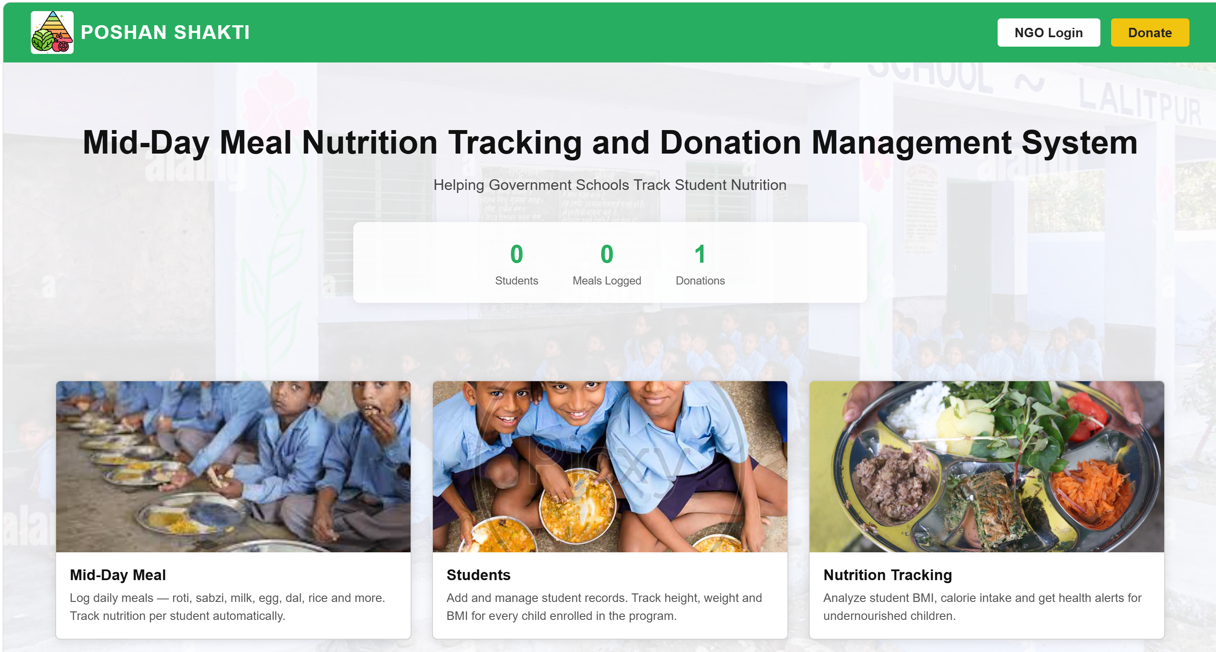

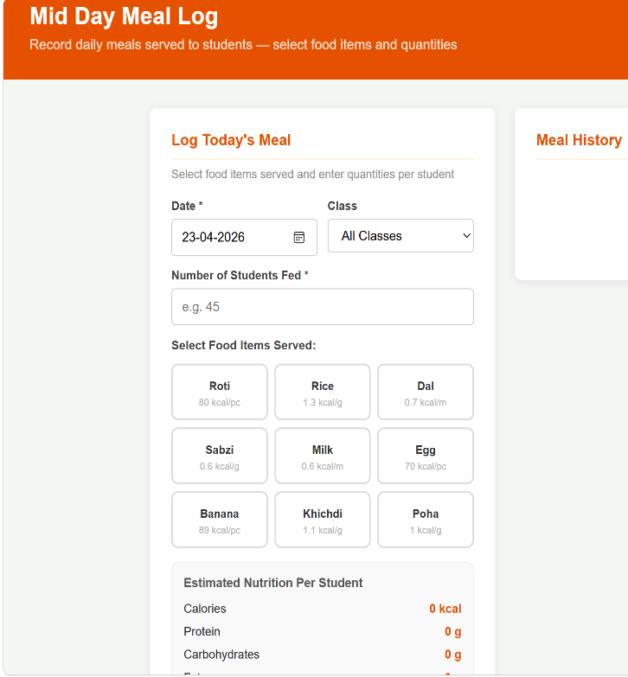
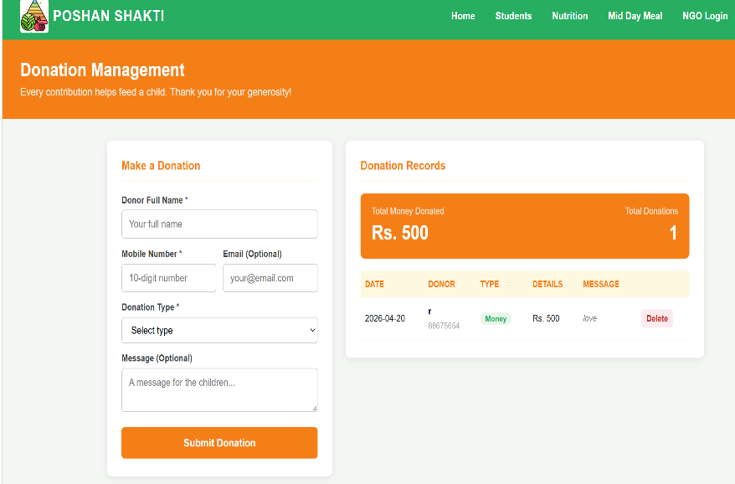
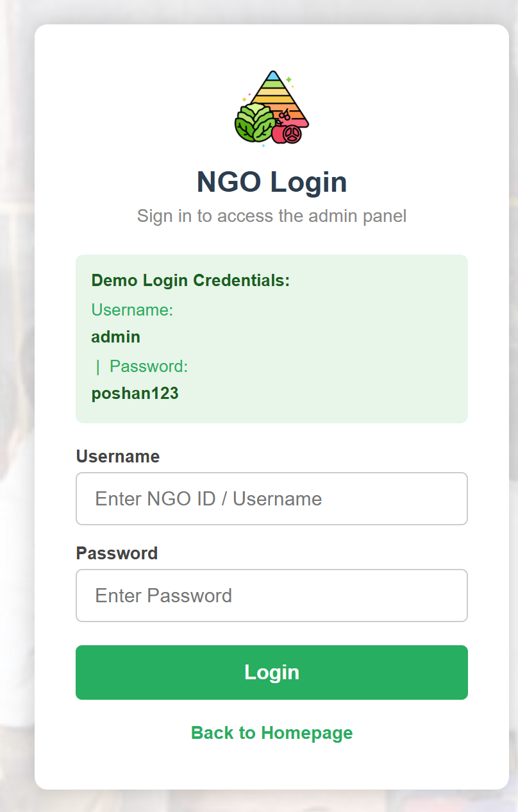
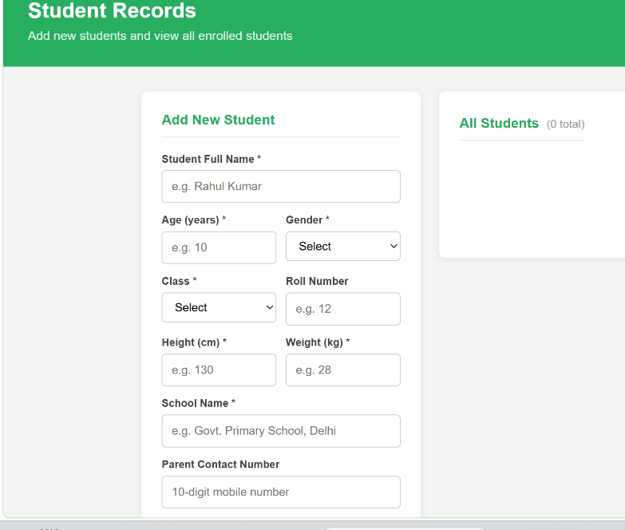

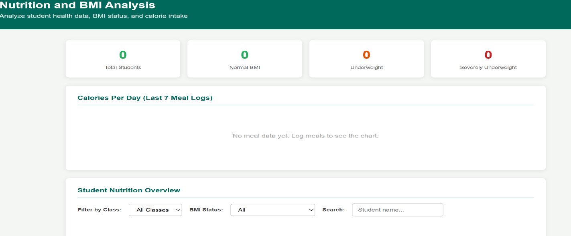
- BIBLOGRAPHY
- Laudon, K. C., & Laudon, J. P. (2020). Management Information Systems: Managing the Digital Firm (16th ed.). Pearson Education.
- Pressman, R. S., & Maxim, B. R. (2020). Software Engineering: A Practitioner's Approach (9th ed.). McGraw-Hill Education.
- Sommerville, I. (2016). Software Engineering (10th ed.). Pearson Education.
- Whitten, J. L., & Bentley, L. D. (2007). Systems Analysis and Design Methods (7th ed.). McGraw-Hill/Irwin.
- Government of India, Ministry of Education. (2023). National Programme of Mid-Day Meals in Schools — Annual Report. Retrieved from https://mdm.nic.in
- Mozilla Developer Network (MDN). (2024). Web APIs — localStorage. Retrieved from https://developer.mozilla.org/en-US/docs/Web/API/Window/localStorage
- Bootstrap Documentation. (2023). Bootstrap 5.3 — Introduction. Retrieved from https://getbootstrap.com/docs/5.3/
- MySQL AB. (2024). MySQL 8.0 Reference Manual. Retrieved from https://dev.mysql.com/doc/refman/8.0/en/
- Indian Council of Medical Research (ICMR). (2020). Dietary Guidelines for Indians. National Institute of Nutrition, Hyderabad.
- World Health Organization (WHO). (2007). BMI-for-age reference standards for children 5–19 years. Retrieved from https://www.who.int/tools/growth-reference-data-for-5to19-years

